**Brain Tumor Detection**



**Submitted By**

Naveed Ahmad (14519)

Umair Khan (14569)

**Session 2017-2022**

**Supervised By**

**Dr Fazal-I- Malik**

A project report submitted to The IQRA National University, Peshawar in partial fulfillment of the requirements for the degree of

**BACHELOR OF SCIENCE (BS) IN COMPUTER SCIENCE**

**DEPARTMENT OF COMPUTER SCIENCE**

**IQRA NATIONAL UNIVERSITY, PESHAWAR-PAKISTAN**

**June, 2022**

**FINAL APPROVAL**

This is certified that I have studied this report, title “**Brain Tumor Detection**” submitted by Usman Khan under the university registration No.ID “Naveed Ahmad (14519), Umair Khan (14569)” We conclude that this project report is of sufficient standard to warrant its acceptance by the **IQRA National University, Peshawar** for the award of degree of Bachelor of Science in Software Engineering BS (CS).

**Viva Voce Examination on Project Report of Naveed Ahmad (14519) Umair Khan (14569) was conducted on 20-05-2022.**

**Approved By:**

__________

Supervisor Name Supervisor

__________

External Examiner Name External Examiner

__________

Internal Examiner Name Internal Examiner

__________

Chairman Name Chairman

**AUTHOR’S DECLARATION**

I hereby declare that I am the sole author of this thesis. This is a true copy of the thesis, including any required final revisions, as accepted by my examinations, its further declared, that I have fulfilled all the requirements in line with the Quality Assurance Guidelines of the Higher Education Commission.

Naveed Ahmad (14519)

Umair Khan (14569)

**ACKNOLEGEMENT**

All acclamation and appreciations are for Al mighty Allah, who bestowed mankind with knowledge and wisdom. I bow before his compassionate endowment. I also pay my respect to last Holy prophet Hazrat Mohammad (PBUH), who becomes to well-wisher of mankind.

I feel great pleasure and honor to express our deepest sense of gratitude and sincere feelings of reverence and regards to my supervisor Mr. Shahab-ul-Islam for his efficient guidance and kind supervision throughout my project. I am extremely thankful to my parents for the humble support, all of my teachers, friends and all those respondents who took part in my project.

Naveed Ahmad (14519)

Umair Khan (14569)

**CONTENTS**

Contents

LIST OF FIGURES viii

LIST OF TABLES viii

LIST OF ACRONYMS x

ABSTRACT xi

CHAPTER 01 INTRODUCTION 12

1.1 Introduction 12

1.2 Brain Tumor 14

1.3 Classification of Brain Tumor 14

1.4 Motivation 15

1.5 Problem Statement 16

1.6 Objectives 16

1.7 Project scope 17

CHAPTER 02 17

2. REQUIREMENT ANALYSIS 17

2.1 Literature Review/Existing system study 18

2.2 Methodology 19

2.2.1 Dataset Description. 19

2.2.2 Data Preprocessing. 20

3. Pre-Processing 20

3. De-noising method 21

4. Thresholding Based Segmentation 21

2.2.3 Watershed Technique. 23

2.3.1. Enhanced Watershed Segmentation (EWS) 23

2.4.1. Image Augmentation Step 24

Implementation of Project 26

2.2.1 Target User: 26

2.2.2 Hardware interface 26

2.2.3 Software interfaces 26

2.2.4 Functional requirement 26

2.2.5 Nonfunctional requirements 27

2.3 Requirements traceability matric 27

2.4 Use case description 27

2.5 Use Case diagram 28

2.6 Software development life cycle 29

2.12 Agile model 30

CHAPTER 03 31

3. SYSTEM DESIGN 31

3.1 Data Flow Diagram DFD 31

3.2 Activity diagram 32

3.8 Graphics user interface 34

Chapter 4 39

4. System Testing 39

CHAPTER 05 41

5. CONCLUSION & SUMMARY 41

5.1 Conclusion 41

5.2 Future work 42

REFERENCES 42

# LIST OF FIGURES

|  |  |  |
| --- | --- | --- |
| Fig. No. | Figure Description | Page No. |
| Figure 1.1 | Benign Tumor (left) and Malignant Tumor (Right) | 15 |
| Figure 1.2 | 2Global age-standardized incidence rate. | 16 |
| Figure 1.3 | Methodology | 19 |
| Figure 2.1 | Use case diagram | 28 |
| Figure 2.2 | Software life cycle diagram | 29 |
| Figure 2.3 | Agile model diagram | 30 |
| Figure 3.1/3.2 | Data flow Diagram | 31 |
| Figure 3.3 | Activity diagram | 32 |
| Figure 3.4 | Graphics user interface /First Frame | 33 |
| Figure 3.5 | Browse Data Set | 34 |
| Figure 3.6 | Tumor Detected | 35 |
| Figure 3.7 | No Tumor | 36 |
| Figure 3.8(a,b) | View Region | 37 |
| Figure 3.9 | Exit | 38 |

# LIST OF TABLES

vi

|  |  |  |
| --- | --- | --- |
| Table. No. | Table Description | Page No. |
| Table 2.1 | Requirement traceability matric test | 15 |
| Table 2.2 | Requirement traceability matric | 15 |
| Table 2.3 | Use case description | 16 |
| Table 4.1 | Test case 1 | 29 |
| Table 4.2 | Test case 2 | 29 |
| Table 4.3 | Test case 3 | 30 |
| Table 4.4 | Test case 4 | 30 |

# LIST OF ACRONYMS

|  |  |
| --- | --- |
| Acronyms | Description |
| INU | IQRA National University |
| BTD | Brain Tumor Detection |
| GUI | Graphical user interface |
| IDE | Integrated development environment |
| PIP | Package Installer for Python |
| VSC | Visual Studio Code |
| MRI | Magnetic resonance imaging |
| App | Application |
| UI | User Interface |
| CNS | Central Nervous system |

# ABSTRACT

Brain tumors are a deadly problem and stop the normal functioning of the human body. For proper diagnosis and effective treatment planning, it is important to detect brain tumors at an early stage. Digital image processing plays an important role in the analysis of medical images. The distribution of brain tumors involves the separation of abnormal brain tissue from normal brain tissue. In the past, various researchers have proposed semi- and fully automated methods for detecting and dividing brain tumors. In this article, various techniques available for distribution are presented. This article focuses on the work that many researchers have done in the past to partially or completely automate the isolation of brain tumors. Comprehensive details of the revised literature are tabulated. The degree of simplicity and human surveillance determines the medical acceptability of a particular segmentation technique.

**Keywords:** Brain Tumor (BT), MRI-Images, CT, X-ray

# CHAPTER 01 INTRODUCTION

# Introduction

In Image processing, edge information is the main clue in image segmentation. But unfortunately, it can’t get a better result in analysis the content of images without combining other information. Therefore, many researchers combine edge information with some other methods to improve the effect of segmentation [1] [2] [3]. Nowadays, the Xray or magnetic resonance images have become two irreplaceable tools for tumors detecting in human brain and other parts of human body [4][5]. Although MRI is more expensive than the X-ray inspection, the development of its applications becomes faster because of the MR inspection does less harm to human than X-ray’s.

Cancer can be defined as the uncontrolled, unnatural growth and division of the cells in the body. Occurrence, as a mass, of these unnatural cell growth and division in the brain tissue is called a brain tumor. While brain tumors are not very common, they are one of the most lethal cancers.

Depending on their initial origin, brain tumors can be considered as either primary brain tumors or metastatic brain tumors. In primary ones, the origin of the cells are brain tissue cells, where in metastatic one’s cells become cancerous at any other part of the body and spread into the brain. Gliomas are type of brain tumors that originate from glial cells. They are the main type of brain tumors that current brain tumor segmentation research focuses on.

The term glioma is a general term that is used to describe different types of gliomas ranging from low-grade gliomas like astrocytoma’s and oligodendroglia’s to the high grade (grade IV) glioblastoma multiform (GBM), which is the most aggressive and the most common primary malignant brain tumor2. Surgery, chemotherapy and radiotherapy are the techniques used, usually in combination; to treat gliomas3 early diagnosis of gliomas plays an important role in improving treatment possibilities. Medical Imaging techniques such as Computed Tomography (CT), Single-Photon Emission Computed Tomography (SPECT), Positron Emission Tomography (PET), Magnetic Resonance Spectroscopy (MRS) and Magnetic Resonance Imaging (MRI) has all used to provide valuable information about shape, size, location and metabolism of brain tumors assisting in diagnosis. While these modalities have used in combination to provide, the highest detailed information about the brain tumors, due to its good soft tissue contrast and widely availability MRI is considered as the standard technique. MRI is a non-invasive in vivo imaging technique that uses radio frequency signals to excite target tissues to produce their internal images under the influence of a very powerful magnetic field. Images of different MRI sequences has generated by altering excitation and repetition times during image acquisition. These different MRI modalities produce different types of tissue contrast images, thus providing valuable structural information and enabling diagnosis and segmentation of tumors along with their subregions4. Four standard MRI modalities used for glioma diagnosis include T1-weighted MRI (T1), T2-weighted MRI (T2), T1-weighted MRI with gadolinium contrast enhancement (T1-Gd) and Fluid Attenuated Inversion Recovery (FLAIR) (see Fig. 1).

During MRI acquisition, although can vary from device to device, around one hundred and fifty slices of 2D images are produced to represent the 3D brain volume. Furthermore, when the slices from the required standard modalities have combined for diagnosis, the data becomes very populated and complicated.

Cancer can be defined as the unbridled, unnatural growth and division of the cells in the body. circumstance, as a mass, of these unnatural cell growth and division in the brain towel is called a brain excrescence. While brain excrescences aren't veritably common, they're one of the most murderous cancers.

The statistics about the death rate from brain tumor suggest that it is one of the most alarming and critical cancer types in the Human body. As per the International Agency of Research on Cancer (IARC), more than 1,000,000 people are diagnosed with brain tumor per year around the world, with ever increasing fatality rate. It is the second most fatal cause of death related to Cancer in children and adults younger than 34 years [1].

Depending on their original origin, brain excrescences can be considered as either primary brain excrescences or metastatic brain excrescences. In primary bones, the origin of the cells are brain towel cells, where in metastatic bone cells come cancerous at any other part of the body and spread into the brain. Gliomas are type of brain excrescences that appear from glial cells. They're the main type of brain excrescences that current brain excrescence segmentation exploration focuses on.

The term glioma is a general term that's used to describe different types of gliomas ranging from low- grade gliomas like astrocytoma’s and oligodendroglia’s to the high grade (grade IV) glioblastoma multiform (GBM), which is the most aggressive and the most common primary nasty brain tumor

Surgery, chemotherapy and radiotherapy are the ways used, generally in combination; to treat gliomas early opinion of gliomas plays an important part in perfecting treatment possibilities. Medical Imaging ways similar as reckoned Tomography (CT), Single- Photon Emission Computed Tomography (SPECT), Positron Emission Tomography (PET), glamorous Resonance Spectroscopy (MRS) and glamorous Resonance Imaging (MRI) has all used to give precious information about shape, size, position and metabolism of brain excrescences aiding in opinion. While these modalities have used in combination to give, the loftiest detailed information about the brain excrescences, due to its good soft towel discrepancy and extensively vacuity MRI is considered as the standard fashion. MRI is an on-invasive in vivo imaging fashion that uses radio frequency signals to excite target to produce their internal images under the influence of a veritably important glamorous field. Images of different MRI sequences has generated by altering excitation and reiteration times during image accession. These different MRI modalities produce different types of towel discrepancy images, therefore furnishing precious structural information and enabling opinion and segmentation of excrescences along with their subregions.

Four standard MRI modalities used for glioma opinion include

T1- ladened MRI(T1),

T2- ladened MRI(T2),

T1- ladened MRI with gadolinium discrepancy improvement (T1- Gd) and

Fluid downgraded Inversion Recovery(faculty).

During MRI accession, although can vary from device to device, around one hundred and fifty slices of 2D images are produced to represent the 3D brain volume. likewise, when the slices from the needed standard modalities have combined for opinion, the data becomes veritably populated and complicated.

# Brain Tumor

According to Ilhan et al. [2], a brain tumor occurs when abnormal cells form within the brain. Many different types of brain tumors exist. Some brain tumors are noncancerous (benign), whereas some brain tumors are cancerous (malignant) and some are pre-malignant. Cancerous tumors can be divided into primary tumors that start within the brain, and secondary tumors that have spread from somewhere else, known as brain metastasis tumors [2].

# Classification of Brain Tumor

There are two types of brain tumor. One is Benign Tumor characterized as non-cancerous and the other one is Malignant Tumor- also known as Cancerous Tumor.

* + 1. **Benign Tumor Benign**

**brain tumors** are usually defined as a group of similar cells that do not follow normal cell division and growth, thus developing into a mass of cells that microscopically do not have the characteristic appearance of a cancer [6].

* These are the properties of a benign tumor:
* Most benign tumors are found by CT or MRI brain scans.
* Grows slowly, do not invade surrounding tissues or spread to other organs, and often have a border or edge that can be seen on CT scans.
* It can be life threatening because they can compress brain tissues and other structures inside the skull, so the term ‘benign’ can be misleading.
  + 1. **Malignant Tumor**

Malignant brain tumors contain cancer cells and often do not have clear borders. They are considered to be life threatening because they grow rapidly and invade surrounding brain tissues [7].

* These are the properties of a malignant tumor:
* Fast growing cancer that spreads to other areas of the brain and spine.
* A malignant brain tumor is either graded 3 or 4, whereas grade 1 or 2 tumors are usually classified as benign or non-cancerous.
* Generally, these are more serious and often more fatal threat to life.

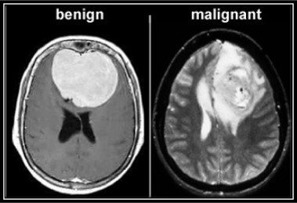

Figure 1.1: Benign Tumor (left) and Malignant Tumor (Right) [8]

# Motivation

Observing the recent statistics of death rate caused by brain tumors, we selected brain tumor detection and classification which belongs to the field of medical image analysis. Tumor detection in medical image is time consuming as it depends on human judgment. The experts in this field, such as radiologists, specialized doctors examine CT scan, MRI, PET scan images and give decisions upon which the treatment depends. This whole process is time consuming. Automated medical image analysis can help to reduce the time and effort taken here and the workload of a human as it will be done by machines.

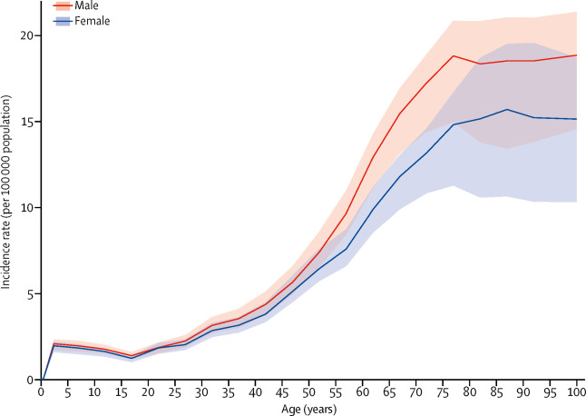

Figure 1.2 Global age-standardized incidence rate per 100 000 population of CNS cancer by age and sex, 2016 [9]

Figure 1.2 shows the incidence of CNS cancers had a peak in early childhood (<5 years of age) and increased after 15 years of age, with no difference in incidence rates by sex during childhood but a diverging incidence between sexes with increasing age, leading to a higher incidence in men than women, albeit this difference was not significant ([figure 2](https://www.thelancet.com/journals/laneur/article/PIIS1474-4422%2818%2930468-X/fulltext#gr2)).

# Problem Statement

Brain tumors are a diverse group of neoplasms of the central nervous system that grow inside or adjacent to the brain. In addition, the location of the tumor inside the brain has a profound effect on the patient's symptoms, surgical treatment options, and the chances of getting a final diagnosis. The location of the tumor in the brain also significantly alters the risk of neurological toxicity that changes the patient's quality of life. Currently, brain tumors are detected by imaging only after the onset of neurological symptoms. There is no early detection strategy in use, even in individuals who are at risk for certain types of brain tumors due to their genetic makeup. The current histopathological classification systems, based on speculated tumor cells, have been in place for almost a century and were updated in 1999 by the World Health Organization. Neither in the individual patient, nor do they guide treatment decision making as patients and physicians hope and need. Current imaging techniques provide complex physical explanations and are the primary tools for establishing that neurological symptom are the result of a brain tumor. There are different techniques and algorithms for detecting brain tumors. I have used edge detection techniques to detect brain tumors.

# Objectives

The main purpose of our project is to provide a platform to meet the needs.

* Critically analyze and evaluate brain tumor identification using image processing.
* Identify major areas of image processing in medicine, especially when detecting brain tumors.
* Study the literature that is based on image processing.
* Identify existing problems in identifying brain tumors.
* Suggest future directions and improvements that can be made in this area.

# Project scope

This project will consist of creating an affordable system in which the design and feature of the system will be evaluated. The listing below will explain the target patients, platform, general features and the workflow of the Project will be going to cover.

* Discuss about image processing techniques.
* Discuss about identification of brain tumor.
* Discuss about how to detect and identify brain tumor using image processing techniques.
* Discuss about the issues in the field

# CHAPTER 02

# 2. REQUIREMENT ANALYSIS

Requirements analysis, often known as requirements engineering, is a method for determining a new product's needs and expectations. It entails constant communication with the product's stakeholders and end-users to establish expectations, manage issues, and document all of the product's important requirements.

Sharing the vision of the finished product with clients is one of the most difficult tasks every company has. As a result, a business requirements study necessitates collaboration among all key stakeholders, software engineers, end-users, and customer managers in order to arrive at a shared understanding of what the product should accomplish. This is always done at the start of a project to ensure that the end product meets all of the specifications.

# 2.1 Literature Review/Existing system study

Artificial intelligence and deep learning are mainly used in image processing techniques for segmentation, identification, and classification of MRI images, and are also used for the classification and detection of brain tumors. Much work has already been done on the classification and segmentation of MRI images of the brain, such as detection of breast cancer via deep convolution neural networks using MRI images [10], Lung Opacity Identification Using Mathematical Model Based On Deep Learning [11], etc.

Badran et al. [12] applied a canny edge detection model, accumulated with adaptive thresholds, to extract ROI. The dataset contained 102 images. The images were first preprocessed and then for two sets of the neural networks, fine edge detection was applied to the first set, and an adaptive threshold was applied to the second set. The segmented image is then represented by a level number, and the features are extracted using the Harris method. Then two neural networks are used, the first to detect a healthy or tumor brain, and the second to determine the type of tumor. By depicting the results and comparing the two models, the canny edge detection method has shown the best results in terms of accuracy.

Soltaninejad et al. [13] combined an extremely randomized tree classification with super pixel-based over-segmentation for a single FLAIR sequence-based MRI scan, which yielded an 88% total bone score of complete tumor segmentation for LGG and HGG tumors. The proposed method was evaluated on two datasets:

**(1) proprietary clinical dataset:** 19 FLAIR MRI images of patients with grade II to IV gliomas and

**(2) BRATS 2012 dataset:** 30 FLAIR images with 10 low grade and 20 high-grade images.

The experimental results have demonstrated a high detection and segmentation efficiency of the proposed method using the ERT classifier with an average sensitivity of 89.48%, BER 6%, and an overlap coefficient Dice of 0.91.

Current methods of brain tumor distribution include generative and discriminatory methods. By incorporating domain-specific prior knowledge, creative approaches generally have good generalizations for invisible images, as they directly model the possible distribution of anatomy and the structural appearance of healthy tissues and tumors. (Menze et al., 2010). However, it is difficult to model the possible distribution of brain tumors. In contrast, discriminating approaches extract features from images and associate features with tissue classes using discriminatory classification. They often need a supervised learning setup where training requires images and vocal war class labels. Classical methods in this category include decision trees (Zikic et al., 2012) and auxiliary vector machines (Lee et al., 2005).

Recently, CNNs have achieved promising results on the work of multimodal brain tumor segmentation as a kind of discriminatory approach. Havaei et al. (2016) Combined local and global 2D features extracted by CNN for brain tumor distribution. Although it performed better than traditional differentiation methods, 2D CNN uses only 2D features without considering the volume context. To add 3D features, it is proposed to implement 2D networks in axial, sagittal and coronal views and fuse their results (McKinley et al., 2016; Li and Shen, 2017; Hu et al.., 2018). However, the features used by this method are from cross-planes rather than the entire 3D space.

# 2.2 Methodology

The proposed work is presented by the data flow diagram with the step-by-step methodology in Figure [1](https://www.hindawi.com/journals/bmri/2022/7348344/fig1/). Firstly, data preprocessing is performed; then, the output images go through the Enhanced Watershed Segmentation (EWS) algorithm technique and find out the contour points of the image. Then, the image augmentation technique is applied to all images and loaded into the modified ResNet50 model (modification done by transfer learning concept), and then, the results are obtained in the form of a ROC graph, model loss, accuracy, precision, specification, and sensitivity of the model.

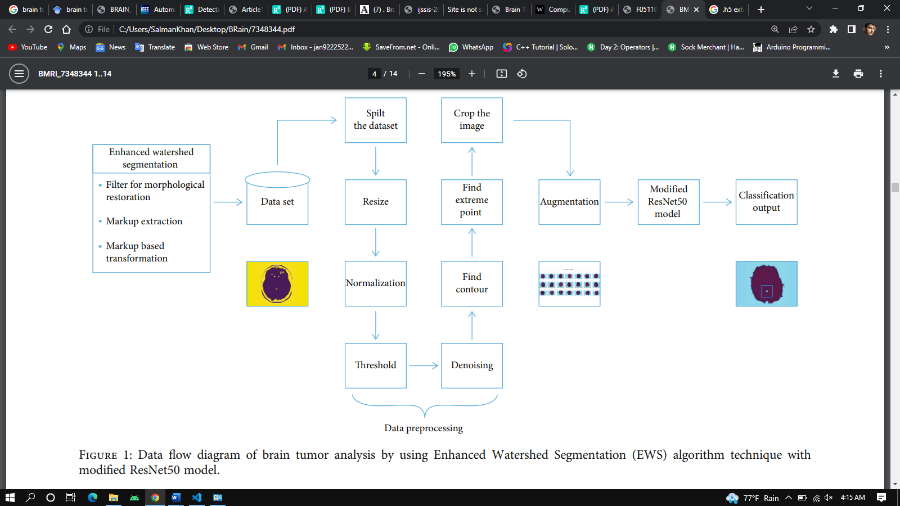

Figure 1.3 Methodology

# 2.2.1 Dataset Description.

In this paper, we have used the dataset from the online platform Kaggle. In this dataset, a total of 253 images exists with different imaging modalities, but we have used only MRI images which are categorized by the proposed method. After that, the dataset is split into three ratios of training, testing, and validation, i.e., (75, 20, 5), (80, 10, 10), and (75, 15, 10). Required software details for the experimental work are a GPU-based system with min 4 Gb RAM and Anaconda environment software setup.

# 2.2.2 Data Preprocessing.

Preprocessing is the preparation of datasets with valuable information and removing unwanted ones. Preprocessing is critical in computer vision, especially in medical image analysis, where inaccurate input can degrade the performance of a very effective classifier. This research involves the usage of three preprocessing stages, MRI image resizing, augmentation, and global pixel normalization, before allocating them to the segmentation stage. The database utilized to investigate with the DL approach is extremely heterogeneous, so effective segmentation requires consisting to resize it with a similar height as well as width. The first step involves preprocessing where the images have been resized and cropped according to the similar width/height consisting of the RGB image as three channel depth. The entire images are resized as 256 × 256 × 3. It has 256 widths and height and 3 depths in RGB. The second stage applies global pixels normalizing to the cropped images. Because each image’s pixel varies from 0 to 255, it is recommended to normalize it between 0 and 1 for better deep learning training. Normalization is the process of converting image pixels to a common scale across all images in a dataset [23]. Global pixel normalization (GPN) is the process to scale pixel data on a given range, often 0-1. While the images inside the database fluctuate from 0 to 255, this is required to increase data from 0 to 1. Using GPN converges the gradient descent faster than ignoring normalization. GPN has also been included for this research as where “y” is the feature vector and and are the minimum and maximum values of the feature vector, respectively.

# 3. Pre-Processing

Pre-processing phase of our project mainly involves those operations that are ordinarily essential before the goal analysis and extraction of the required data and ordinarily geometric corrections of the initial image. These enhancements embrace correcting the information for irregularities and unwanted region noise, removal of non-brain element image and converting the data so that they are correctly reflected in the original image. The first step of preprocessing is the conversion of the given input MRI image into a suitable form on which further work can be performed.

This conversion of DICOM image to .jpeg is done by using function dicom2image () [7]. Major issues related to the preprocessing stage are as follows: - a. Noise

1. Blur Low Contrast
2. The bias
3. The partial-volume effect

This pre-processing stage is used for reducing image noise, highlighting important portions, or displaying obvious portions of digital images.

# 3. De-noising method

In spite of the presence of considerable variety of state-of-the-art ways of de-noising however correct removal of noise from magnetic resonance imaging image is a challenge. Here, Wavelet based method is been used as a denoising. In frequency domain this method is used for de noising and preserving the actual signal. This builds the scaling coefficients freelance of the signal and therefore are often simply removed. We have used the Wavelet toolbox in mat lab [18] and used lifting wavelet transform (LWT) [17] functions that are lwt2 (), ilwt2 (), lwtcoef2 (). By the help of these functions noise is been removed from the taken input that is the MRI image. These functions make it possible to recover weak signals from noise and the processed image in this way can be cleaned up without blurring or losing the clarity.

    # noise removal

    def removeNoise(self):

        self.kernel = np.ones((3, 3), np.uint8)

        opening = cv.morphologyEx(self.thresh, cv.MORPH_OPEN, self.kernel, iterations=2)

        self.curImg = opening

# 4. Segmentation

Nowadays, brain tumor segmentation methods can be organized into different categories based on different principles. In the clinic, brain tumor segmentation methods are usually classified into three main categories including manual, semi-automatic, and fully automatic segmentations based on the degree of required human interaction [18-19]. For manual brain tumor segmentation, the experts of brain tumor must master the information presented in the brain tumor images and some additional knowledge such as anatomy because manual brain tumor segmentation aims to manually draw the boundaries of the brain tumor and paint the regions of anatomic structures with different labels [19]. To date, manual segmentation is widely applied to clinical trial. In the clinic, since many of brain tumor images are emerging, the manual segmentation of the different regions of brain tumor will become an error-prone and time-consuming task for the experts and yield poor results in a way. Therefore, more advanced segmentation methods such as semi-automatic and fully automatic segmentation methods are required to address this problem. For semi-automatic brain tumor segmentation, it mainly consists of the user, interaction, and software computing. In the semi-automatic brain tumor methods, the user needs to input some parameters and is responsible for analyzing the visual information and providing feedback response for the software computing. The software computing is targeted at the realization of brain tumor segmentation algorithms. The interaction is in charge of adjusting segmentation information between the user and the software computing. The semi-automatic brain tumor segmentation methods were divided into three main processes: initialization, feedback response, and evaluation [18]. Although brain tumor semi-automatic segmentation methods can obtain better results than manual segmentation, it also comes into being different results from different experts or the same user at different times. Hence, fully automatic brain tumor segmentation methods were proposed. For fully automatic brain tumor segmentation, the computer determines the segmentation of brain tumor without any human interaction. In general, a fully automatic segmentation algorithm combines artificial intelligence and prior knowledge. With the development of machine learning algorithms that can simulate the intelligence of humans to learn effectively, the study of fully automatic brain tumor segmentation has become a popular research issue. The semi-automatic and fully automatic segmentation of tumor brain images are faced with great challenges due to usually exhibiting unclear and irregular boundaries with discontinuities and partial-volume effects for brain tumor images. This paper divides the current MRI-based brain tumor segmentation methods into three major categories: conventional methods, classification and clustering methods, and deformable model methods.

# 4.1 Conventional methods

Conventional brain tumor segmentation methods mainly include the use of standard image processing methods such as threshold-based methods [20, 21] and region-based methods [20]. Threshold-based and region-based methods are commonly employed in two-dimensional image segmentation [21].

# 4.1.1 Threshold-based methods

Threshold-based method is a simple and effective segmentation method by comparing their intensities with one or more intensity thresholds. At present, threshold-based methods are classified into global and local thresholding’s. If an image contains objects with homogeneous intensity or the contrast between the objects, and the background is high, global thresholding is the best choice to segment the objects and the backgrounds. When the contrast of an image is low, threshold selection will become difficult. Local thresholding can be determined by estimating a threshold value for the different regions from the intensity histogram. The threshold values of local thresholding are generally estimated by using the local statistical properties such as the mean intensity value in T1w MRI, by the prior knowledge and by calculating partial volumes of each region to determine the threshold for the segmentation of each component [21]. In addition, the Gaussian distribution was applied to determine the thresholds in normal brain MRI image [22]. Due to the special structure of brain tumor, global and local thresholding’s are mainly used to determine the approximate location of brain tumor in the brain. In most cases, thresholding is used as the first step in the segmentation process of brain tumor.

# 4.1.2 Region-based methods:

Region-based segmentation methods examine pixels in an image and form disjoint regions by merging neighborhood pixels with homogeneity properties based on a predefined similarity criterion [23]. The region growing and the watershed segmentation methods are part of the region-based methods and are generally used in the process of brain tumor segmentation. The region growing is the simplest and most commonly region-based segmentation method and is used to extract a connected region of similar pixels from an image [24]. Region growing starts with at least one seed that belongs to the structure of interest. Neighbors of the seed are checked and those satisfying the similarity criteria are added to the region. The similarity criteria are determined by a range of pixel intensity values or other features in the image. Seeds can be chosen manually or provided by an automatic seed-finding procedure [25]. The procedure iterates until no more pixels can be added to the region. The advantage of region growing is that it is capable of correctly segmenting regions that have similar properties and generating connected region. Some researchers have proved that the region growing is an effective approach and less computation intensive than other non-region-based methods for segmenting MR images of brain tumors, especially for the homogeneous tissues and regions [26, 27]. The primary disadvantage of region growing method is the partial volume effect which limits the accuracy of MR brain image segmentation. Partial volume effect blurs the intensity distinction between different tissue classes at the border of the two tissues types, because the voxel may represent more than one kind of tissue types [26]. Some segmentation methods incorporate the region growing process as a refinement step [27]. A fuzzy information fusion framework was proposed for the automatic segmentation of brain tumor using MRI [28]. The registration of multispectral images was the first step for the creation of this framework including a priori knowledge, fuzzy feature fusion, and an adjustment by fuzzy region growing. The basic principle of watershed segmentation method can be explained by a metaphor based on the behavior of water in a landscape. When it rains, drops of water falling in different regions will follow the landscape downhill. The water will end up at the bottom of valleys. For each valley there will be a region from which all water drains into it. At points where water comes from different basins meets, dams will be built. When the water level reaches the highest peak in the landscape, the process is stopped. As a result, the landscape is partitioned into regions separated by dams, called watershed lines or watersheds. Some researchers used multi-scale watershed transformation to segment brain tumors [29, 30]. An analysis of user-assisted hierarchical watershed segmentation methods of brain tumors from MRI data was performed [31]. The quantitative and qualitative results showed that the segmentation time and precision were improved significantly and it outperformed manual segmentation. The analysis also identified some disadvantages in the watershed method for brain tumor segmentation. To improve these disadvantages, some methods had been proposed. A multi-parameter watershed segmentation algorithm that was used for detection of tumor in 2-D and 3-D brain MRI was proposed [32]. A marker-based improved watershed algorithm by utilizing the prior knowledge of the test images for the segmentation of brain tumors was proposed [33]. The watershed segmentation methods usually suffer from over-segmentation. To avoid over segmentation and produce a reasonable segmentation, some advanced methods have been proposed [34-35] . In conclusion, the good results of brain tumor segmentation by using conventional methods are hard to achieve. In most situations, these methods were used as a preprocessing step in the segmentation of brain tumor. Therefore, more advanced automatic methods were proposed to accord with the requirements of clinical doctors.

By segmentation in this project means the method of partitioning a picture to many segments however the most difficulties in segmenting are associated with degree of pictures and pictures is also non-inheritable within the continuous domain like on X-ray film, or in distinct house as in MRI. In 2-D distinct pictures, the placement of every activity is termed an element and in 3-D pictures, it's referred to as a voxel. For simplicity, typically we use the term ‘pixel’ to see each the 2-D and 3-D cases

When the constraint that regions be connected is removed, then determinant the sets referred to as pixel classification and also the sets themselves are called classes. Pixel classification instead of classical segmentation is usually a fascinating goal in medical pictures, significantly once disconnected regions happens to a similar tissue category ought to be known.

Thresholding is based on a threshold-value or clip-level to convert a gray-scale image into a binary image and segments the region of interests. There are various types of thresholding methods which are depicted below:

# 4.2.1. Binary Thresholding:

Debnath et al. [36] presented their algorithm which includes thresholding for tumor segmentation. Converting 24-Bit Color Images to 256 Gray Color Images and Calculating histograms the resulting images were converted to a binary thresholder image, histograms were calculated and at last edge detection algorithm was used [37].

# 4.2.2. Adaptive or Dynamic Thresholding:

Different thresholds for different regions of the same image is calculated in this approach [37]. Badran et al. [38] tried two different segmentation techniques in their work and among them, one is adaptive thresholding.

# 4.2.3. Otsu Thresholding:

This algorithm presumes that the image encompasses two classes of pixels following bi-modal histogram [38]. Mittal et al. [29] used Otsu Thresholding segmentation along with watershed technique, asserting that Otsu’s thresholding chooses the threshold for minimizing the intra-class variance of the thresholder black and white pixels.

def predictTumor(image):

    gray = cv.cvtColor(image, cv.COLOR_BGR2GRAY)

    gray = cv.GaussianBlur(gray, (5, 5), 0)

    # Threshold the image, then perform a series of erosions +

    # dilations to remove any small regions of noise

    thresh = cv.threshold(gray, 45, 255, cv.THRESH_BINARY)[1]

    thresh = cv.erode(thresh, None, iterations=2)

    thresh = cv.dilate(thresh, None, iterations=2)

    # Find contours in thresholded image, then grab the largest one

    cnts = cv.findContours(thresh.copy(), cv.RETR_EXTERNAL, cv.CHAIN_APPROX_SIMPLE)

    cnts = imutils.grab_contours(cnts)

    c = max(cnts, key=cv.contourArea)

    # Find the extreme points

    extLeft = tuple(c[c[:, :, 0].argmin()][0])

    extRight = tuple(c[c[:, :, 0].argmax()][0])

    extTop = tuple(c[c[:, :, 1].argmin()][0])

    extBot = tuple(c[c[:, :, 1].argmax()][0])

    # crop new image out of the original image using the four extreme points (left, right, top, bottom)

    new_image = image[extTop[1]:extBot[1], extLeft[0]:extRight[0]]

    image = cv.resize(new_image, dsize=(240, 240), interpolation=cv.INTER_CUBIC)

    image = image / 255.

    image = image.reshape((1, 240, 240, 3))

    res = model.predict(image)

    return res

# 5. Watershed Technique.

On a gray-scale image, a watershed is a transition. Image morphology is used to segment regions in watershed segmentation. To segment regions, the watershed uses regional minima as seeds. It is a hybrid method that combines boundary and region-based growing techniques. (This transformation could be considered as a topographic region growing method.) At least one seed point must be chosen inside of each object in the image, including the backdrop. The markers are chosen manually or automatically depending on the application-specific information included in the objects. After the objects have been marked, morphological watershed transformation can be used to grow them. The watershed, on the other hand, is a standard segmentation technique for separating objects in a picture. Pixel data is treated as a local topography by the watershed method (elevation). The watershed segmentation methods treat an image as a topographic relief, with the value of each image element indicating the image’s height at that location. In the study, the term element is utilized to merge the notions of pixel and voxel. Rather than the original image, watershed segmentation is frequently applied to the result of the image’s distance transform.

# 6. Enhanced Watershed Segmentation (EWS)

Filter for Morphological Restoration. The standard resmoothing filter reduces noise and irregular features well, but it loses contour edge information, causing a change in the region contour [24]. The edge shape data of the objective can be very much protected when filtering and denoising the MRI picture of the chest tumor. It also does not produce a shift in the contour of the rebuilt image. Morphological restoration is defined as

(1

shows a morphological restoration image of mask y reformed by the x (marker image), where StEl is the structural element, x is the real image, Mn is the last iteration resultant image, and M0 is the initial iteration of y.

Equation (1) is iterated as far as possible when Mn+1 = Mn. Since morphological restoration might eliminate surface components and brilliant commotion more modest than underlying components, morphological shut rebuilding can do likewise and recuperate the objective edge. Notwithstanding, using just morphological or shut reclamation can just dispense with one commotion or detail from the picture, causing a change in the objective form’s position. The surface subtleties and concealing clamor can be eliminated simultaneously when the crossbreed introductory and last rebuilding activities are utilized. The picture morphology rebuilding is utilized to expand the limit data while diminishing the quantity of pseudo least qualities when the half, half starting, and last reclamation activities are utilized. The morphological initial and final restoration action based on the initial and final actions is defined as

(2

where is the initial action restoration and is the final action restoration.

# 7. Step

The proposed brain tumor detection through a machine learning algorithm involves four basic techniques such as data processing, transfer learning technique as the ResNet50 model, feature extraction, and segmentation. The designed novel also is shown in Algorithm 1. The two types of augmentation techniques used in the proposed work are as follows:

1. Geometric transformations: in this technique, randomly flip, crop, rotate, or translate images, and that is just the tip of the iceberg as the given value.
2. Color space transformations: change RGB color channels and intensify any color.

In the proposed algorithm, firstly, load and import the dataset and then split it into the three-part training set, test set, and validation data. After that, select any one original image and apply the biggest contour to find out the extreme point. Then, crop the image and save it. Apply this function to all images. Further, resize all images on the same scale. After that, apply augmentation techniques on the training dataset to increase the number of images in the dataset for model training. Figure 2 shows the image set of the brain tumor (input). Figure 3 shows the resized image. Figure 4 shows data augmentation on the original image. Figure 5 shows the augmented images. We have used two types of augmentation techniques in the proposed work:

1. Geometric transformations: in this technique, the image is randomly flipped, cropped, rotated, or translated.
2. Color space transformations: in this technique, any color is intensified and the HSV channel is changed to an RGB color channel.

class DisplayTumor:

    curImg = 0

    Img = 0

    def readImage(self, img):

        self.Img = np.array(img)

        self.curImg = np.array(img)

        gray = cv.cvtColor(np.array(img), cv.COLOR_BGR2GRAY)

        self.ret, self.thresh = cv.threshold(gray, 0, 255, cv.THRESH_BINARY_INV + cv.THRESH_OTSU)

    def getImage(self):

        return self.curImg

    # noise removal

    def removeNoise(self):

        self.kernel = np.ones((3, 3), np.uint8)

        opening = cv.morphologyEx(self.thresh, cv.MORPH_OPEN, self.kernel, iterations=2)

        self.curImg = opening

    def displayTumor(self):

        # sure background area

        sure_bg = cv.dilate(self.curImg, self.kernel, iterations=3)

        # Finding sure foreground area

        dist_transform = cv.distanceTransform(self.curImg, cv.DIST_L2, 5)

        ret, sure_fg = cv.threshold(dist_transform, 0.7 * dist_transform.max(), 255, 0)

        # Find unknown region

        sure_fg = np.uint8(sure_fg)

        unknown = cv.subtract(sure_bg, sure_fg)

        # Marker labelling

        ret, markers = cv.connectedComponents(sure_fg)

        # Add one to all labels so that sure background is not 0, but 1

        markers = markers + 1

        # Now mark the region of unknown with zero

        markers[unknown == 255] = 0

        markers = cv.watershed(self.Img, markers)

        self.Img[markers == -1] = [255, 0, 0]

        tumorImage = cv.cvtColor(self.Img, cv.COLOR_HSV2BGR)

        self.curImg = tumorImage

**4.3.1 FCM algorithms**

FCM is a method of clustering which divides one group of data into two or more clusters. This method [41] is frequently used in pattern recognition. Straight speaking, this algorithm works by assigning membership to each data point corresponding to each cluster center on the basis of distance between the cluster and the data point. The nearer the data is to the cluster center the more possible its membership towards the particular cluster center is. The advantages of FCM algorithm include:

(1) Giving the best result for overlapped data set and comparatively better than means algorithm.

(2) Unlike k-means where data point must exclusively belong to one cluster center, assigning the membership of data points to more than one cluster center. As a result, a data point may belong to more than one cluster center.

(3) The application of FCM to MR data has shown encouraging results [42]. Therefore, FCM for segmenting brain tumors is becoming a fruitful research area. In the study of brain tumor segmentation, brain tumor was segmented into tissue classes including active cells, necrotic core, and edema using unsupervised FCM clustering algorithm [43]. Using this algorithm, it is possible to generate segmentation images that display clinically important neuroanatomic and neuropathologic tissue contrast information from raw MR image data. Subsequently, some researchers incorporate additional information into the feature vectors being clustered using FCM. The MRI images are processed by a system which integrates knowledge-based methods with multispectral histogram analysis was proposed to deal with the segmentation of brain tumor [44]. A knowledge-based fuzzy clustering approach was proposed and implemented for the segmentation of the MRI images of brain tumor followed by 3-D connected components to build the tumor shape [46]. Based on fuzzy knowledge and modified seeded region growing, a novel image segmentation method called Fuzzy Knowledgebase Seeded Region Growing (FKSRG) was proposed [45]. Experimental results demonstrate that the FKSRG method segments multispectral MR images much more effectively than the functional MRI of the Brain Automated Segmentation Tool, k-means, and SVM methods. Since FCM is an iterative algorithm, it is considered as a very time-consuming clustering method. In order to reduce the execution time of this algorithm, some solutions such as Fast Generalized FCM (FGFCM) clustering algorithms and Bias Corrected FCM (BCFCM) algorithm have been proposed. A novel fast and robust FCM framework was introduced for brain tumor segmentation called FGFCM clustering algorithms by incorporating local information [47]. BCFCM algorithm provides good quality segmented brain images in a very quick way, which makes it an excellent tool to support virtual brain endoscopy to realize the segmentation of brain tumor [48]. In order to reduce the sensitivity of the standard FCM algorithm with Gaussian, impulse, and intensity non-uniformity noises, a modified FCM-based method that targets accurate and fast segmentation in case of mixed noises was proposed [49]. This method extracts a scalar feature value from the neighborhood of each pixel, using a context dependent filtering technique that deals with both spatial and gray level distances. These features are clustered afterwards by the histogram-based approach of the enhanced FCM algorithm. In order to improve the performance of FCM algorithm, some researchers have introduced a neighborhood attraction, which is dependent on the relative location and features of neighboring pixels. However, determination of degree of attraction is a challenging task which can considerably affect the segmentation results. The Genetic Algorithms (GAs) are good at reaching a near optimal solution but have trouble finding an exact solution while Particle Swarm Optimization (PSO) enhances the search for an optimal solution. The combination of GAs and PSO was presented to determine the optimum value of degree of attraction [50]. To improve the accurate determination of stage and size of tumor, a combined method of the k-means and fuzzy c-means algorithms was proposed to deal with the segmentation of brain tumor [51]. This method allows the segmentation of tumor tissue with accuracy and reproducibility comparable to manual segmentation. In addition, it also reduces the time for the progress of the segmentation.

# 8. Implementation of Project

In our system need below requirements to develop and run the brain tumor project.

# 8.1 Target User:

The system will target patients and doctors**.**

# 8.2 Hardware interface

This application required a laptop or PC.

This app also requires the internet connection.

# 8.3 Software interfaces

Operating system windows 10.

Tools Visual Studio Code

Python 3.10.4

Technologies used python, TensorFlow, OpenCV.

Real device: Dell Laptop.

# 8.4 Functional requirement

User (Doctor) Select the MRI Image of.

View the result of image that are Tumor Detected or not.

View the detected brain.

# 8.5 Nonfunctional requirements

**Reliability:** the degree of something that perform a required operation without any failure and to be accurate is the reliability.

**Maintainability** the software will be mange application will be updated and modified time by time.

**Portability** Software are easy to transferred from one OS to other files are easy for the transfer.

# 8.6 Requirements traceability matric

**Table 2.1:** Requirements traceability matric

|  |  |  |  |
| --- | --- | --- | --- |
| **Requirement ID** | **Requirement description** | **Test case ID** | **Status** |
| 01 | Start Application | Tc01 | Tc01 pass |
| 02 | Browse Images | Tc02 | Tc02 pass |
| 03 | Select Image and View | Tc03 | Tc03 pass |

**Table 2.2:** Requirements traceability matric

|  |  |  |  |
| --- | --- | --- | --- |
| **Requirement ID** | **Requirement description** | **Test case ID** | **Status** |
| 01 | Check Detection | Tc01 | Tc01 pass |
| 02 | View Detected Brain | Tc02 | Tc02 pass |
| 03 | Exit | Tc03 | Tc03 pass |

# 2.4 Use case description

**Table 2.3:** Use case description

|  |  |
| --- | --- |
| Use case | Description |
| Run | In this use case user run the app. |
| Browse Images | Click on browse button for selecting images. |
| Select image | After selecting image will be display in Image frame (Photo Image). |
| Detect Tumor Detect | Clicking the Detect Tumor radio button and view the result on label. |
| View Tumor Regin | Police can view the location of user in emergency. |

# 2.5 Use Case diagram

Use case diagram is the primary form of system requirements for a new software program underdeveloped use cases specify the expected behavior and not the exact method of making it happen use cases once specified can be denoted both textual and visual representation. Use case modeling is that it helps us design a system from the end user perspective

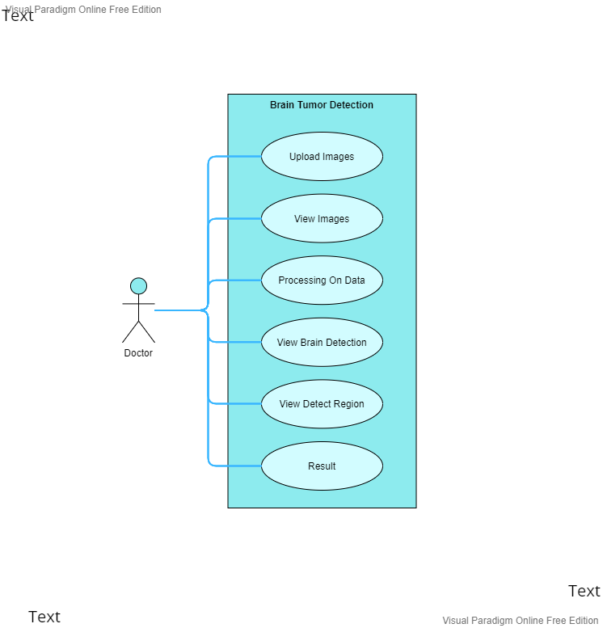

**Figure 2.1:** Use case diagram

# 2.6 Software development life cycle

As in the start we didn’t clear requirement of our project so we use hybrid software development life cycle model it means we mixes two SDLC models to achieve our desired output.

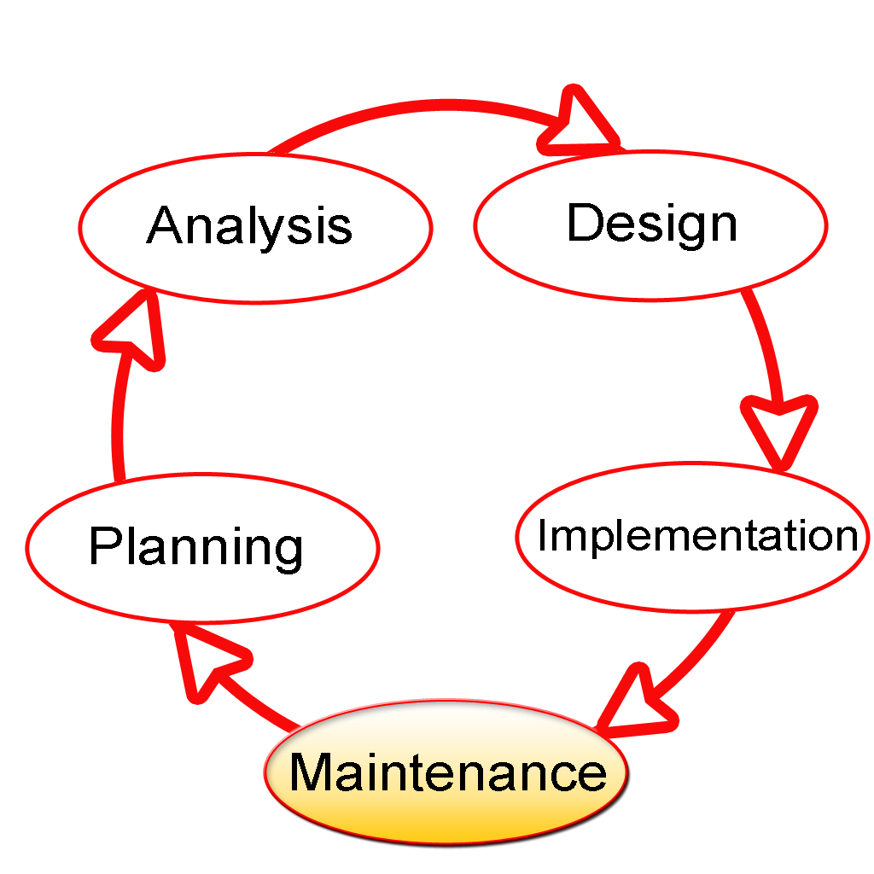

**Figure 2.2:** Software development life cycle

# 2.12 Agile model

The Agile SDLC model is a combination of repetitive and incremental process models that focus on customer satisfaction through process adaptation and fast delivery of working software products. Active methods break down the product into smaller incremental bleeds. These constructions are provided in repetition.

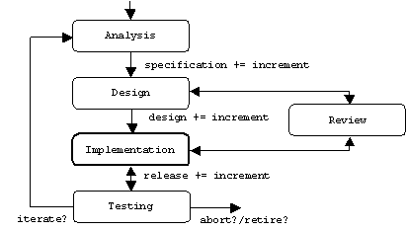

**Figure 2.3: Agile model**

# CHAPTER 03

# 3. SYSTEM DESIGN

System design is the process of defining the components, modules, interfaces and data for a system to satisfy specified requirement system development is the process of creating or altering systems, along with the process, practices, models, and methodologies used to develop them.

A systemic approach is essential for a well-functioning and coherent system. To take into consideration all of the system's connected variables, a bottom-up or top-down strategy is required. A designer employs modelling languages to describe information and knowledge in a system structure that is determined by a set of consistent rules and definitions. Graphical or textual modelling languages can be used to create the designs.

# 3.1 Data Flow Diagram DFD

Data Flow Diagrams are a graphical tool used to describe and analyze the movement of data through a system. DFD’s are used to capture the essential feature of both existing real system and future physical implementation of the system. The DFD is a graphical technique that depicts the information flow and the transforms that are applies as data move from input to the output.

1. Level-0 DFD Shows outline of the System Models

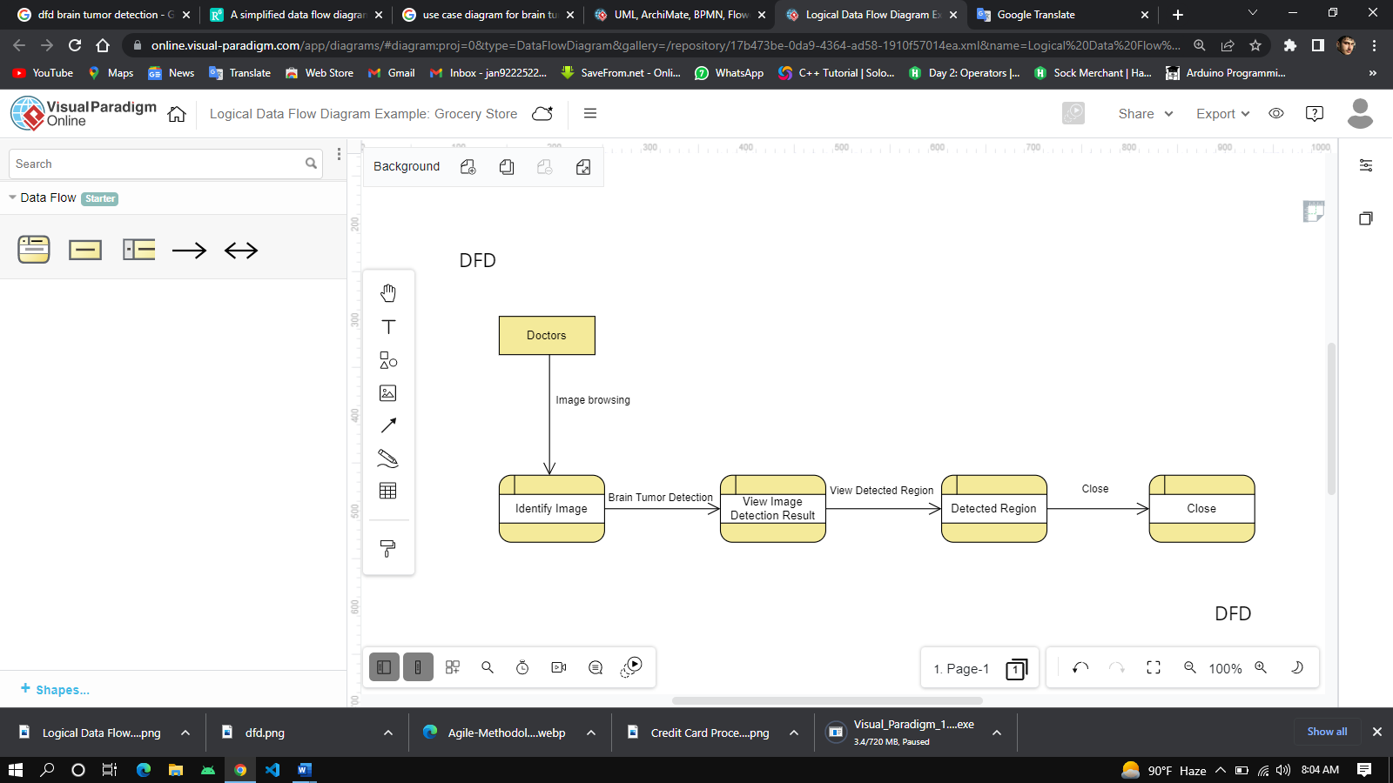

**Figure 3.1:** DFD

1. Level-1 DFD

This shows the separation of all external modules, relationship between those modules and the application

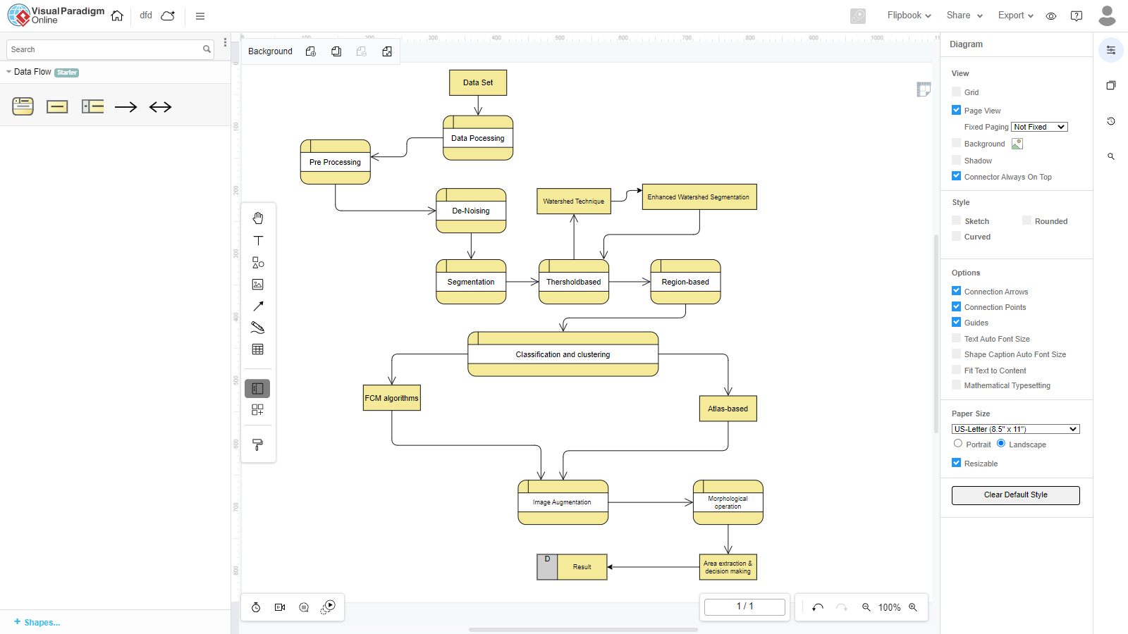

**Figure 3.2:** DFD

# 3.2 Activity diagram

Activity diagrams describe how activities are coordinated to provide a service which can at different levels of abstraction Typically, an event needs to be achieved by some operations particularly where.

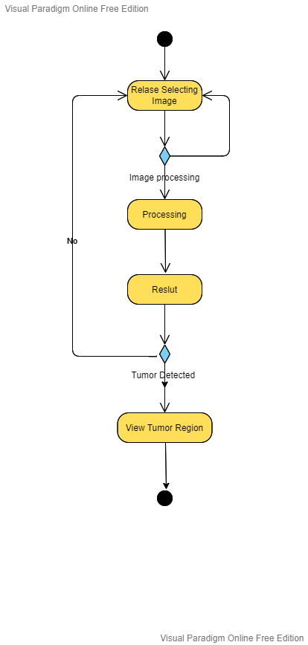

**Figure 3.3:** Activity diagram

**Description**

The diagram above is an outline of my GUI software activity which is briefly described above. Activity layout begins with the appropriate user interface. The processing phase is performed on segmentation. Input images in threshold segmentation, the input gray scale image is converted to binary. The format is performed after the watershed segmentation.

Which is usually used to check the output instead of using it as input. Segmentation technique because it usually suffers from high segmentation and under-segmentation. After converting the image to binary format, some morphological operations are applied to the converted binary image. The purpose of morphological operators is to isolate the tumor portion of the image. Now only the tumor part of the image is visible, which is shown as white.  
Morphological operators are being applied at a time when image processing has been a useful tool for processing medical images and its use and benefits are growing rapidly in this modern technological world. Using some of the image processing techniques we have been able to develop an algorithm that is useful for detecting abnormal formation of cells in the brain. Here we present an approach that detects tumors inside the brain. In this proposed algorithm, we have used a series of image enhancement techniques and then a series of morphological techniques to detect tumors in the brain. After applying the frequency domain method, we apply the histogram magnification technique. This is a technique that can be used to improve the visual appearance of an image. We applied the histogram magnification technique to the FFT image with the aim of obtaining uniform intensity values ​​throughout the image using the histogram technique with the aim that the next step of our proposed procedure would be the image.

Thresholding is a common image processing technique on images in which they are relatively fewer interesting objects whose shape is more important than surface features. Here we use thresholding as a segmentation algorithm to segment the desired part of the image, in which case we want to segment the tumor. Here we first analyze the histogram of the image obtained after the histogram magnification technique. After analyzing the image histogram, we select a suitable value for T, the limit value. We then apply the selected value to the image. After dividing the abnormal areas using thresholding, we then apply a series of morphological operations. Morphological operation is a branch of image processing used to represent, describe and analyze shapes in images. The basic neighborhood structure associated with morphological operations is a structural element. Structural elements play an important role in the morphological operation. They shape and size affect the results of applying a specific morphological operator to an image. In the algorithm, we first apply Erosion, the effect of which is to shrink or thin objects. This operation is controlled by the size and shape of the structural element. Then we spread, which has the effect of making things thicker or thicker. The structural element also plays a central role in this operation. Then we implement operations that are made up of a combination of basic operations (cut and spread) such as opening and closing operations.

# 3.8 Graphics user interface

A computer program that enables a person to communicate with a computer through the use of symbols, visual metaphors, and pointing devices.

**First Frame:**

The main frames where have some labels for instruction and some button to perform a specific action. Browse is used for image file opening to select images.

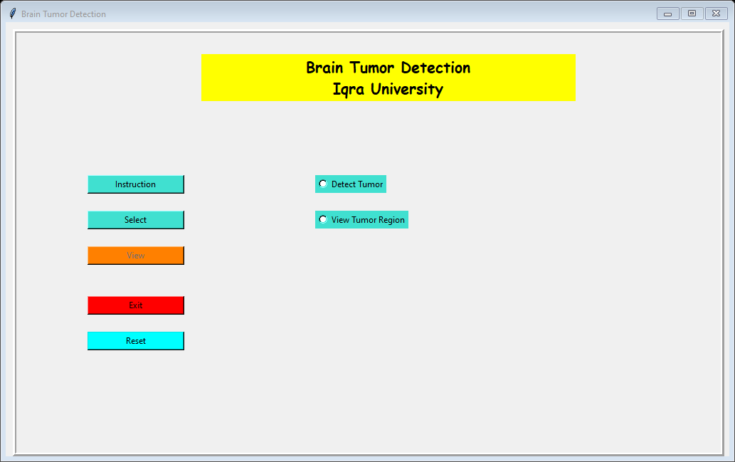

**Figure 3.4:** First Frame

**Introduction:**

Click on introduction to view the dialog window to show the steps of using the app.

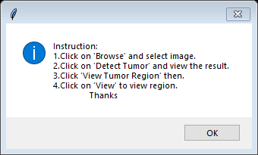

**Figure 3.5:** Introduction

**Browse Image (data set):**

Click on browse to view the dataset and select the images.

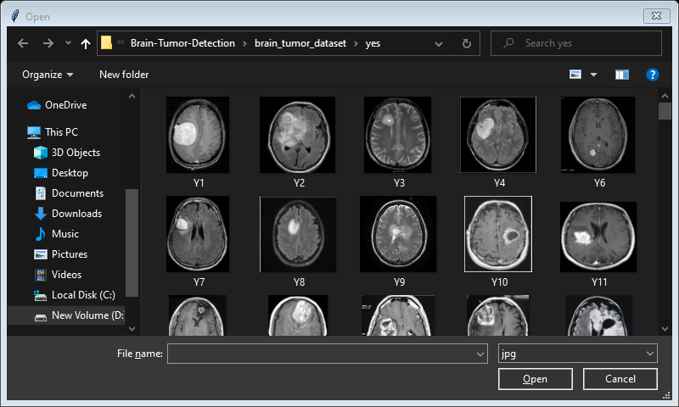

**Figure 3.6:** Browse Data set

**Tumor Detect**

When a doctor selects the image and then click on tumor detect after image processing the result will be show at the label.

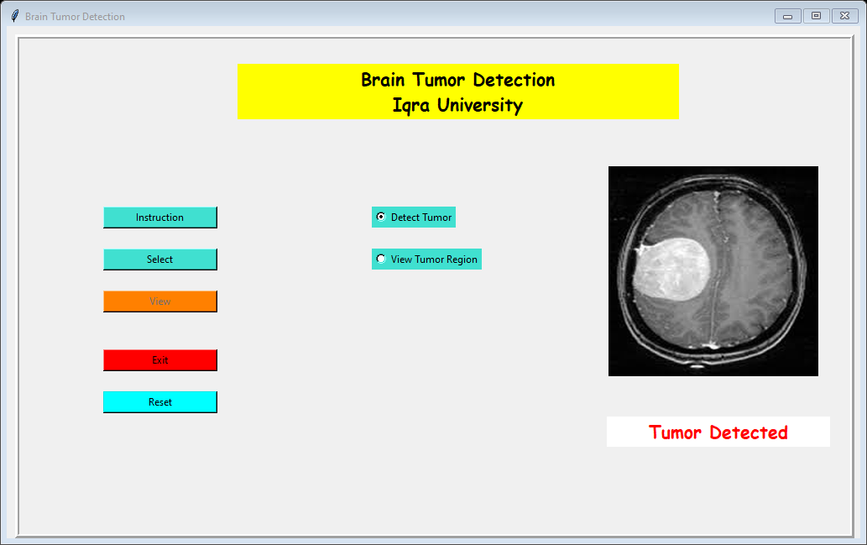

**Figure 3.7:** Tumor Detect

**No Tumor**

When a doctor selects the image and then click on tumor detect after image processing the result will be show at the label. Here the result will be show at the label in the green color.

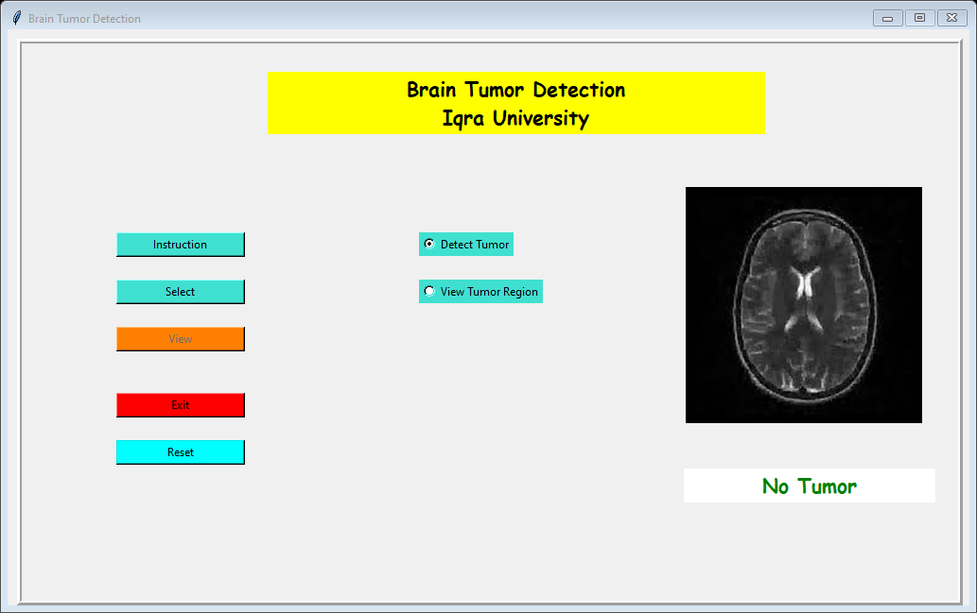

**Figure 3.8:** NoTumor

**View Region:**

The region of brain that are tumor detected will be show at the first step in black and white and this is shown the brain circle or area. After clicking again, the view button to view the affected area of brain.

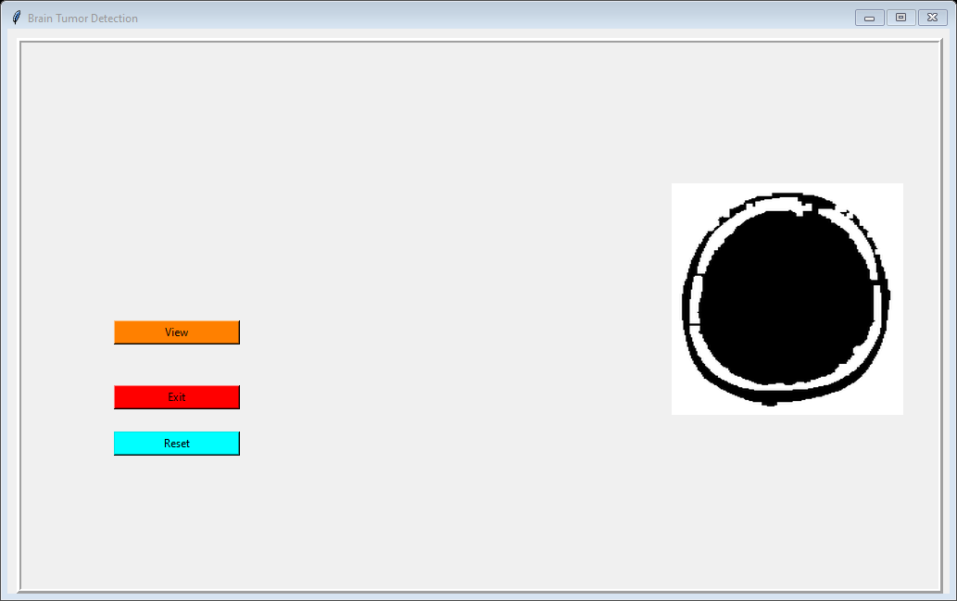

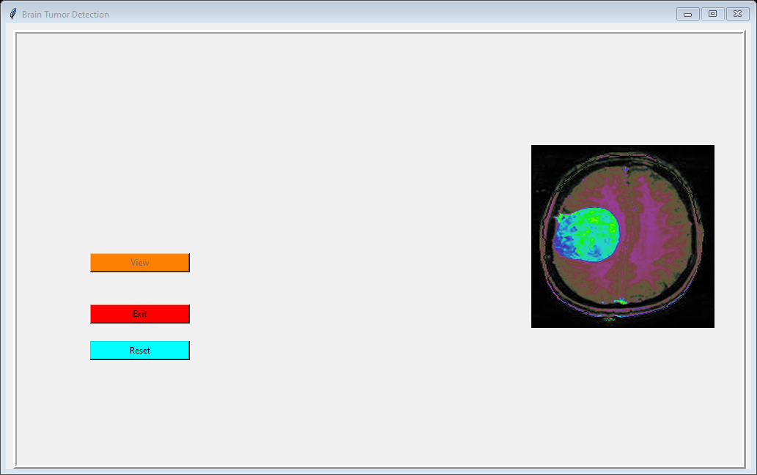

**Figure 3.9(a/b):**  View Region

**Reset**

This button is use to reset the program to insert and implement new dataset.



**Figure 4.0:**  Reset

**Exit**

The last option is exit user can easily exit or close the app.

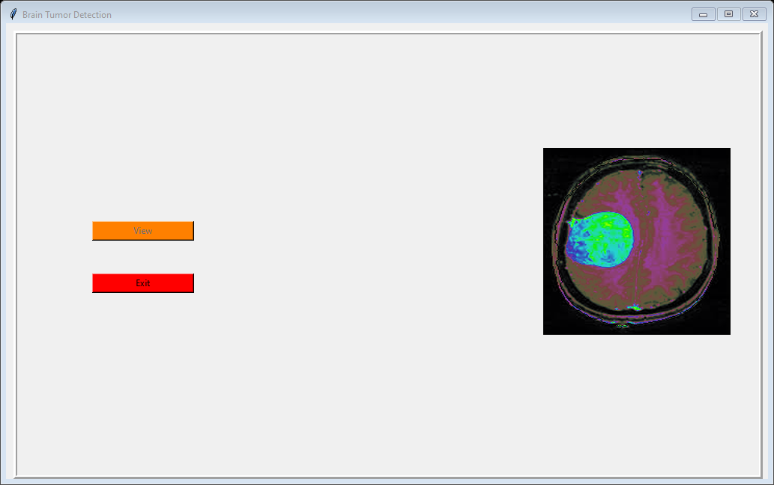

**Figure 4.1:**  Exit

# Chapter 4

# System Testing

System testing is a level of testing that validates the complete and fully integrated software product the purpose of a system test is to evaluate the end-to-end system specification. Usually, the software is only one element of a larger computer-based system. Ultimately the software is interfaced with other software/hardware systems.

System testing is actually the series of different tests whose sole purposes is to exercise the full computer-based system. The steps taken towards performing the test is basically opening functioning application code and unit tests then run each unit test.

**Table 4.1:** Test Case 1

|  |  |  |
| --- | --- | --- |
| **Test Case Description** | **Test Data** | **Status** |
| Start Debugging | Running | Test case pass |

**Table 4.**2: Test Case 2

|  |  |  |  |  |  |
| --- | --- | --- | --- | --- | --- |
| **Test Scenario** | **Test steps** | **Test Data** | **Expected result** | **Actual results** | **Pass/Fail** |
| Check dataset | 1. Browse image 2. Select image | Data set | Success fetch and view selected image | As expected, | Pass |
| Check no tumor | 1. Select image 2. Run image 3. Image processing 4. View result | Data set Image name (n10) | No Tumor | As expected, | Pass |

**Table 4.3:** Test Case 3

|  |  |  |  |  |  |
| --- | --- | --- | --- | --- | --- |
| **Test Scenario** | **Test steps** | **Test Data** | **Expected result** | **Actual results** | **Pass/Fail** |
| Check  brain tumor  detection | Select image  Run image  Image processing  View result | Data set  Image name (y1) | Tumor detected | As expected, | Pass |
| View Region | Click on view region  view the region of detected image | Data set  Image name (y1) | Viewed the  region of tumor | As expected, | Pass |

**4.2 Unit/Integration/Acceptance Testing**

**Table 4.4:** Test case 4

|  |  |  |
| --- | --- | --- |
| **Test#** | **Test** | **Requirement** |
| 1 | Start | All test pass |
| 2 | Browse | All test pass |
| 3 | Select image | All test pass |
| 4 | View image | All test pass |
| 5 | Tumor detected | All test pass |
| 6 | No Tumor | All test pass |
| 7 | View region | All test pass |
| 8 | Close | All test pass |

# CHAPTER 05

# CONCLUSION & SUMMARY

# 5.1 Conclusion

In this proposed work, we obtain an MRI image of the brain and perform a series of operations to increase the quality of the image and then isolate the tumor inside the brain. This algorithm is able to clearly divide the tumor and outline the shape and location of the tumor. As a result, it helps the doctor to analyze the shape and size of the tumor as the shape and size of the tumor plays an important role in the treatment of the tumor. In the future, we will focus on simple algorithms to calculate tumor area and thinness. We will also use simple algorithms to calculate the location of the tumor.

Performance analysis of automated brain tumor detection from MR imaging and CT scan using basic image processing techniques based on various hard and soft computing has been performed in our work. Moreover, we applied six traditional classifiers to detect brain tumor in the images. Then we applied CNN for brain tumor detection to include deep learning method in our work. We compared the result of the traditional one having the best accuracy (SVM) with the result of CNN. Furthermore, our work presents a generic method of tumor detection and extraction of its various features. In the context of the full dataset, it is necessary to parallelize and utilize high-performance computing platform for maximum efficiency. We tried our best to detect the tumors accurately but, nevertheless we faced some problems in our work where tumor could not be detected or falsely detected. So, we will try to work on those images and on the complete dataset. Hence, we will try to apply other deep learning methods in the future so that we can get a more precise and better result.

# 5.2 Future work

Future development of the project is the computer technology keeps finding new methods and technologies on a day-to-day basis. It is dynamic and not static. The skills which is prominent today will become obsolete in a few days. To keep in pace with the technical developments, the system may be additionally improved. So, it is not concluded. Yet it will improve with further augmentations. Augmentations can be done in an effectual manner. We can even apprise the same with further changes and can be integrated with minimal alteration. Thus, the project is flexible and can be improved at any time with more progressive features. Here we mention some important future work.

* + - 1. Store data in database.
      2. All data will be display in mobile app doctor can easily access of any user record.

**Limitation:**

* The BRATS dataset has only 241 images
* Worked only on 2D images.
* We could have tried more traditional classifiers to increase the accuracy.
* Types of the tumor could not be classified.

# REFERENCES

1. L. Guo, L. Zhao, Y. Wu, Y. Li, G. Xu, and Q. Yan, “Tumor detection in MR images using one-class immune feature weighted SVMs,” IEEE Transactions on Magnetics, vol. 47, no. 10, pp. 3849–3852, 2011.View at: [Publisher Site](https://doi.org/10.1109/TMAG.2011.2158520) | [Google Scholar](https://scholar.google.com/scholar_lookup?title=Tumor%20detection%20in%20MR%20images%20using%20one-class%20immune%20feature%20weighted%20SVMs&author=L.%20Guo&author=L.%20Zhao&author=Y.%20Wu&author=Y.%20Li&author=G.%20Xu&author=&author=Q.%20Yan&publication_year=2011)
2. R. Kumari, “SVM classification an approach on detecting abnormality in brain MRI images,” International Journal of Engineering Research and Applications, vol. 3, pp. 1686–1690, 2013.View at: [Google Scholar](https://scholar.google.com/scholar_lookup?title=SVM%20classification%20an%20approach%20on%20detecting%20abnormality%20in%20brain%20MRI%20images&author=R.%20Kumari&publication_year=2013)
3. American Brain Tumor Association, [http://www.abta.org](http://www.abta.org/).
4. N. Gordillo, E. Montseny, and P. Sobrevilla, “State of the art survey on MRI brain tumor segmentation,” Magnetic Resonance Imaging, vol. 31, no. 8, pp. 1426–1438, 2013.View at: [Publisher Site](https://doi.org/10.1016/j.mri.2013.05.002) | [Google Scholar](https://scholar.google.com/scholar_lookup?title=State%20of%20the%20art%20survey%20on%20MRI%20brain%20tumor%20segmentation&author=N.%20Gordillo&author=E.%20Montseny&author=&author=P.%20Sobrevilla&publication_year=2013)
5. A. Demirhan, M. Toru, and I. Guler, “Segmentation of tumor and edema along with healthy tissues of brain using wavelets and neural networks,” IEEE Journal of Biomedical and Health Informatics, vol. 19, no. 4, pp. 1451–1458, 2015.View at: [Publisher Site](https://doi.org/10.1109/jbhi.2014.2360515) | [Google Scholar](https://scholar.google.com/scholar_lookup?title=Segmentation%20of%20tumor%20and%20edema%20along%20with%20healthy%20tissues%20of%20brain%20using%20wavelets%20and%20neural%20networks&author=A.%20Demirhan&author=M.%20Toru&author=&author=I.%20Guler&publication_year=2015)
6. S. Madhukumar and N. Santhiyakumari, “Evaluation of k-Means and fuzzy C-means segmentation on MR images of brain,” Egyptian Journal of Radiology and Nuclear Medicine, vol. 46, no. 2, pp. 475–479, 2015.View at: [Publisher Site](https://doi.org/10.1016/j.ejrnm.2015.02.008) | [Google Scholar](https://scholar.google.com/scholar_lookup?title=Evaluation%20of%20k-Means%20and%20fuzzy%20C-means%20segmentation%20on%20MR%20images%20of%20brain&author=S.%20Madhukumar%20&author=N.%20Santhiyakumari&publication_year=2015)
7. Y. Kong, Y. Deng, and Q. Dai, “Discriminative clustering and feature selection for brain MRI segmentation,” IEEE Signal Processing Letters, vol. 22, no. 5, pp. 573–577, 2015.View at: [Publisher Site](https://doi.org/10.1109/LSP.2014.2364612) | [Google Scholar](https://scholar.google.com/scholar_lookup?title=Discriminative%20clustering%20and%20feature%20selection%20for%20brain%20MRI%20segmentation&author=Y.%20Kong&author=Y.%20Deng&author=&author=Q.%20Dai&publication_year=2015)
8. M. T. El-Melegy and H. M. Mokhtar, “Tumor segmentation in brain MRI using a fuzzy approach with class center priors,” EURASIP Journal on Image and Video Processing, vol. 2014, article no. 21, 2014.View at: [Publisher Site](https://doi.org/10.1186/1687-5281-2014-21) | [Google Scholar](https://scholar.google.com/scholar_lookup?title=Tumor%20segmentation%20in%20brain%20MRI%20using%20a%20fuzzy%20approach%20with%20class%20center%20priors&author=M.%20T.%20El-Melegy%20&author=H.%20M.%20Mokhtar&publication_year=2014)
9. G. Coatrieux, H. Huang, H. Shu, L. Luo, and C. Roux, “A watermarking-based medical image integrity control system and an image moment signature for tampering characterization,” IEEE Journal of Biomedical and Health Informatics, vol. 17, no. 6, pp. 1057–1067, 2013.View at: [Publisher Site](https://doi.org/10.1109/JBHI.2013.2263533) | [Google Scholar](https://scholar.google.com/scholar_lookup?title=A%20watermarking-based%20medical%20image%20integrity%20control%20system%20and%20an%20image%20moment%20signature%20for%20tampering%20characterization&author=G.%20Coatrieux&author=H.%20Huang&author=H.%20Shu&author=L.%20Luo&author=&author=C.%20Roux&publication_year=2013)
10. S. Damodharan and D. Raghavan, “Combining tissue segmentation and neural network for brain tumor detection,” International Arab Journal of Information Technology, vol. 12, no. 1, pp. 42–52, 2015.View at: [Google Scholar](https://scholar.google.com/scholar_lookup?title=Combining%20tissue%20segmentation%20and%20neural%20network%20for%20brain%20tumor%20detection&author=S.%20Damodharan%20&author=D.%20Raghavan&publication_year=2015)
11. M. Alfonse and A.-B. M. Salem, “An automatic classification of brain tumors through MRI using support vector machine,” Egyptian Computer Science Journal, vol. 40, pp. 11–21, 2016.View at: [Google Scholar](https://scholar.google.com/scholar_lookup?title=An%20automatic%20classification%20of%20brain%20tumors%20through%20MRI%20using%20support%20vector%20machine&author=M.%20Alfonse%20&author=A.-B.%20M.%20Salem&publication_year=2016)
12. Q. Ain, M. A. Jaffar, and T.-S. Choi, “Fuzzy anisotropic diffusion based segmentation and texture based ensemble classification of brain tumor,” Applied Soft Computing Journal, vol. 21, pp. 330–340, 2014.View at: [Publisher Site](https://doi.org/10.1016/j.asoc.2014.03.019) | [Google Scholar](https://scholar.google.com/scholar_lookup?title=Fuzzy%20anisotropic%20diffusion%20based%20segmentation%20and%20texture%20based%20ensemble%20classification%20of%20brain%20tumor&author=Q.%20Ain&author=M.%20A.%20Jaffar&author=&author=T.-S.%20Choi&publication_year=2014)
13. E. Abdel-Maksoud, M. Elmogy, and R. Al-Awadi, “Brain tumor segmentation based on a hybrid clustering technique,” Egyptian Informatics Journal, vol. 16, no. 1, pp. 71–81, 2014.View at: [Publisher Site](https://doi.org/10.1016/j.eij.2015.01.003) | [Google Scholar](https://scholar.google.com/scholar_lookup?title=Brain%20tumor%20segmentation%20based%20on%20a%20hybrid%20clustering%20technique&author=E.%20Abdel-Maksoud&author=M.%20Elmogy&author=&author=R.%20Al-Awadi&publication_year=2014)
14. E. A. Zanaty, “Determination of gray matter (GM) and white matter (WM) volume in brain magnetic resonance images (MRI),” International Journal of Computer Applications, vol. 45, pp. 16–22, 2012.View at: [Google Scholar](https://scholar.google.com/scholar_lookup?title=Determination%20of%20gray%20matter%20(GM)%20and%20white%20matter%20(WM)%20volume%20in%20brain%20magnetic%20resonance%20images%20(MRI)&author=E.%20A.%20Zanaty&publication_year=2012)
15. T. Torheim, E. Malinen, K. Kvaal et al., “Classification of dynamic contrast enhanced MR images of cervical cancers using texture analysis and support vector machines,” IEEE Transactions on Medical Imaging, vol. 33, no. 8, pp. 1648–1656, 2014.View at: [Publisher Site](https://doi.org/10.1109/TMI.2014.2321024) | [Google Scholar](https://scholar.google.com/scholar_lookup?title=Classification%20of%20dynamic%20contrast%20enhanced%20MR%20images%20of%20cervical%20cancers%20using%20texture%20analysis%20and%20support%20vector%20machines&author=T.%20Torheim&author=E.%20Malinen&author=K.%20Kvaal%20et%20al.&publication_year=2014)
16. J. Yao, J. Chen, and C. Chow, “Breast tumor analysis in dynamic contrast enhanced MRI using texture features and wavelet transform,” IEEE Journal on Selected Topics in Signal Processing, vol. 3, no. 1, pp. 94–100, 2009.View at: [Publisher Site](https://doi.org/10.1109/JSTSP.2008.2011110) | [Google Scholar](https://scholar.google.com/scholar_lookup?title=Breast%20tumor%20analysis%20in%20dynamic%20contrast%20enhanced%20MRI%20using%20texture%20features%20and%20wavelet%20transform&author=J.%20Yao&author=J.%20Chen&author=&author=C.%20Chow&publication_year=2009)
17. P. Kumar and B. Vijayakumar, “Brain tumour Mr image segmentation and classification using by PCA and RBF kernel based support vector machine,” Middle-East Journal of Scientific Research, vol. 23, no. 9, pp. 2106–2116, 2015.View at: [Google Scholar](https://scholar.google.com/scholar_lookup?title=Brain%20tumour%20Mr%20image%20segmentation%20and%20classification%20using%20by%20PCA%20and%20RBF%20kernel%20based%20support%20vector%20machine&author=P.%20Kumar%20&author=B.%20Vijayakumar&publication_year=2015)
18. N. Sharma, A. Ray, S. Sharma, K. Shukla, S. Pradhan, and L. Aggarwal, “Segmentation and classification of medical images using texture-primitive features: application of BAM-type artificial neural network,” Journal of Medical Physics, vol. 33, no. 3, pp. 119–126, 2008.View at: [Publisher Site](https://doi.org/10.4103/0971-6203.42763) | [Google Scholar](https://scholar.google.com/scholar_lookup?title=Segmentation%20and%20classification%20of%20medical%20images%20using%20texture-primitive%20features:%20application%20of%20BAM-type%20artificial%20neural%20network&author=N.%20Sharma&author=A.%20Ray&author=S.%20Sharma&author=K.%20Shukla&author=S.%20Pradhan&author=&author=L.%20Aggarwal&publication_year=2008)
19. W. Cui, Y. Wang, Y. Fan, Y. Feng, and T. Lei, “Localized FCM clustering with spatial information for medical image segmentation and bias field estimation,” International Journal of Biomedical Imaging, vol. 2013, Article ID 930301, 8 pages, 2013.View at: [Publisher Site](https://doi.org/10.1155/2013/930301) | [Google Scholar](https://scholar.google.com/scholar_lookup?title=Localized%20FCM%20clustering%20with%20spatial%20information%20for%20medical%20image%20segmentation%20and%20bias%20field%20estimation&author=W.%20Cui&author=Y.%20Wang&author=Y.%20Fan&author=Y.%20Feng&author=&author=T.%20Lei&publication_year=2013)
20. G. Wang, J. Xu, Q. Dong, and Z. Pan, “Active contour model coupling with higher order diffusion for medical image segmentation,” International Journal of Biomedical Imaging, vol. 2014, Article ID 237648, 8 pages, 2014.View at: [Publisher Site](https://doi.org/10.1155/2014/237648) | [Google Scholar](https://scholar.google.com/scholar_lookup?title=Active%20contour%20model%20coupling%20with%20higher%20order%20diffusion%20for%20medical%20image%20segmentation&author=G.%20Wang&author=J.%20Xu&author=Q.%20Dong&author=&author=Z.%20Pan&publication_year=2014)
21. A. Chaddad, “Automated feature extraction in brain tumor by magnetic resonance imaging using gaussian mixture models,” International Journal of Biomedical Imaging, vol. 2015, Article ID 868031, 11 pages, 2015.View at: [Publisher Site](https://doi.org/10.1155/2015/868031) | [Google Scholar](https://scholar.google.com/scholar_lookup?title=Automated%20feature%20extraction%20in%20brain%20tumor%20by%20magnetic%20resonance%20imaging%20using%20gaussian%20mixture%20models&author=A.%20Chaddad&publication_year=2015)
22. S. N. Deepa and B. Arunadevi, “Extreme learning machine for classification of brain tumor in 3D MR images,” Informatologia, vol. 46, no. 2, pp. 111–121, 2013.View at: [Google Scholar](https://scholar.google.com/scholar_lookup?title=Extreme%20learning%20machine%20for%20classification%20of%20brain%20tumor%20in%203D%20MR%20images&author=S.%20N.%20Deepa%20&author=B.%20Arunadevi&publication_year=2013)
23. J. Sachdeva, V. Kumar, I. Gupta, N. Khandelwal, and C. K. Ahuja, “Segmentation, feature extraction, and multiclass brain tumor classification,” Journal of Digital Imaging, vol. 26, no. 6, pp. 1141–1150, 2013.View at: [Publisher Site](https://doi.org/10.1007/s10278-013-9600-0) | [Google Scholar](https://scholar.google.com/scholar_lookup?title=Segmentation,%20feature%20extraction,%20and%20multiclass%20brain%20tumor%20classification&author=J.%20Sachdeva&author=V.%20Kumar&author=I.%20Gupta&author=N.%20Khandelwal&author=&author=C.%20K.%20Ahuja&publication_year=2013)
24. S. Lal and M. Chandra, “Efficient algorithm for contrast enhancement of natural images,” International Arab Journal of Information Technology, vol. 11, no. 1, pp. 95–102, 2014.View at: [Google Scholar](https://scholar.google.com/scholar_lookup?title=Efficient%20algorithm%20for%20contrast%20enhancement%20of%20natural%20images&author=S.%20Lal%20&author=M.%20Chandra&publication_year=2014)
25. C. C. Benson and V. L. Lajish, “Morphology based enhancement and skull stripping of MRI brain images,” in Proceedings of the International Conference on Intelligent Computing Applications (ICICA '14), pp. 254–257, Tamilnadu, India, March 2014.View at: [Publisher Site](https://doi.org/10.1109/icica.2014.61) | [Google Scholar](https://scholar.google.com/scholar_lookup?title=Morphology%20based%20enhancement%20and%20skull%20stripping%20of%20MRI%20brain%20images&author=C.%20C.%20Benson%20&author=V.%20L.%20Lajish)
26. S. Z. Oo and A. S. Khaing, “Brain tumor detection and segmentation using watershed segmentation and morphological operation,” International Journal of Research in Engineering and Technology, vol. 3, no. 3, pp. 367–374, 2014.View at: [Publisher Site](https://doi.org/10.15623/ijret.2014.0303068) | [Google Scholar](https://scholar.google.com/scholar_lookup?title=Brain%20tumor%20detection%20and%20segmentation%20using%20watershed%20segmentation%20and%20morphological%20operation&author=S.%20Z.%20Oo%20&author=A.%20S.%20Khaing&publication_year=2014)
27. R. Roslan, N. Jamil, and R. Mahmud, “Skull stripping magnetic resonance images brain images: region growing versus mathematical morphology,” International Journal of Computer Information Systems and Industrial Management Applications, vol. 3, pp. 150–158, 2011.View at: [Google Scholar](https://scholar.google.com/scholar_lookup?title=Skull%20stripping%20magnetic%20resonance%20images%20brain%20images:%20region%20growing%20versus%20mathematical%20morphology&author=R.%20Roslan&author=N.%20Jamil&author=&author=R.%20Mahmud&publication_year=2011)
28. S. Mohsin, S. Sajjad, Z. Malik, and A. H. Abdullah, “Efficient way of skull stripping in MRI to detect brain tumor by applying morphological operations, after detection of false background,” International Journal of Information and Education Technology, vol. 2, no. 4, pp. 335–337, 2012.View at: [Publisher Site](https://doi.org/10.7763/ijiet.2012.v2.145) | [Google Scholar](https://scholar.google.com/scholar_lookup?title=Efficient%20way%20of%20skull%20stripping%20in%20MRI%20to%20detect%20brain%20tumor%20by%20applying%20morphological%20operations,%20after%20detection%20of%20false%20background&author=S.%20Mohsin&author=S.%20Sajjad&author=Z.%20Malik&author=&author=A.%20H.%20Abdullah&publication_year=2012)
29. B. Willmore, R. J. Prenger, M. C. Wu, and J. L. Gallant, “The Berkeley wavelet transform: a biologically inspired orthogonal wavelet transform,” Neural Computation, vol. 20, no. 6, pp. 1537–1564, 2008.View at: [Publisher Site](https://doi.org/10.1162/neco.2007.05-07-513) | [Google Scholar](https://scholar.google.com/scholar_lookup?title=The%20Berkeley%20wavelet%20transform:%20a%20biologically%20inspired%20orthogonal%20wavelet%20transform&author=B.%20Willmore&author=R.%20J.%20Prenger&author=M.%20C.%20Wu&author=&author=J.%20L.%20Gallant&publication_year=2008) | [Zentralblatt MATH](https://www.zentralblatt-math.org/zmath/en/advanced/?q=an%3A1136.92310) | [MathSciNet](https://www.ams.org/mathscinet-getitem?mr=MR2410367)
30. P. Remya Ravindran and K. P. Soman, “Berkeley wavelet transform based image watermarking,” in Proceedings of the International Conference on Advances in Recent Technologies in Communication and Computing (ARTCom '09), pp. 357–359, IEEE, Kerala, India, October 2009.View at: [Publisher Site](https://doi.org/10.1109/artcom.2009.201) | [Google Scholar](https://scholar.google.com/scholar_lookup?title=Berkeley%20wavelet%20transform%20based%20image%20watermarking&author=P.%20Remya%20Ravindran%20&author=K.%20P.%20Soman)
31. I. M. Alwan and E. M. Jamel, “Digital image watermarking using Arnold scrambling and Berkeley wavelet transform,” Al-Khwarizmi Engineering Journal, vol. 12, pp. 124–133, 2015.View at: [Google Scholar](https://scholar.google.com/scholar_lookup?title=Digital%20image%20watermarking%20using%20Arnold%20scrambling%20and%20Berkeley%20wavelet%20transform&author=I.%20M.%20Alwan%20&author=E.%20M.%20Jamel&publication_year=2015)
32. R. M. Haralick, K. Shanmugam, and I. Dinstein, “Textural features for image classification,” IEEE Transactions on Systems, Man and Cybernetics, vol. 3, no. 6, pp. 610–621, 1973.View at: [Publisher Site](https://doi.org/10.1109/tsmc.1973.4309314) | [Google Scholar](https://scholar.google.com/scholar_lookup?title=Textural%20features%20for%20image%20classification&author=R.%20M.%20Haralick&author=K.%20Shanmugam&author=&author=I.%20Dinstein&publication_year=1973)
33. J. Liu, M. Li, J. Wang, F. Wu, T. Liu, and Y. Pan, “A survey of MRI-based brain tumor segmentation methods,” Tsinghua Science and Technology, vol. 19, no. 6, pp. 578–595, 2014.View at: [Publisher Site](https://doi.org/10.1109/tst.2014.6961028) | [Google Scholar](https://scholar.google.com/scholar_lookup?title=A%20survey%20of%20MRI-based%20brain%20tumor%20segmentation%20methods&author=J.%20Liu&author=M.%20Li&author=J.%20Wang&author=F.%20Wu&author=T.%20Liu&author=&author=Y.%20Pan&publication_year=2014) | [MathSciNet](https://www.ams.org/mathscinet-getitem?mr=MR3295921)
34. A. P. Nanthagopal and R. Sukanesh, “Wavelet statistical texture features-based segmentation and classification of brain computed tomography images,” IET Image Processing, vol. 7, no. 1, pp. 25–32, 2013.View at: [Publisher Site](https://doi.org/10.1049/iet-ipr.2012.0073) | [Google Scholar](https://scholar.google.com/scholar_lookup?title=Wavelet%20statistical%20texture%20features-based%20segmentation%20and%20classification%20of%20brain%20computed%20tomography%20images&author=A.%20P.%20Nanthagopal%20&author=R.%20Sukanesh&publication_year=2013) | [MathSciNet](https://www.ams.org/mathscinet-getitem?mr=MR3076547)
35. V. Anitha and S. Murugavalli, “Brain tumor classification based on clustered discrete cosine transform in compressed domain,” Journal of Computer Science, vol. 10, no. 10, pp. 1908–1916, 2014.View at: [Publisher Site](https://doi.org/10.3844/jcssp.2014.1908.1916) | [Google Scholar](https://scholar.google.com/scholar_lookup?title=Brain%20tumor%20classification%20based%20on%20clustered%20discrete%20cosine%20transform%20in%20compressed%20domain&author=V.%20Anitha%20&author=S.%20Murugavalli&publication_year=2014)
36. Parveen and A. Singh, “Detection of brain tumor in MRI images, using combination of fuzzy c-means and SVM,” in Proceedings of the 2nd International Conference on Signal Processing and Integrated Networks (SPIN '15), pp. 98–102, February 2015.View at: [Publisher Site](https://doi.org/10.1109/spin.2015.7095308) | [Google Scholar](https://scholar.google.com/scholar_lookup?title=Detection%20of%20brain%20tumor%20in%20MRI%20images,%20using%20combination%20of%20fuzzy%20c-means%20and%20SVM&author=%20Parveen%20&author=A.%20Singh)
37. K. Dhanalakshmi and V. Rajamani, “An intelligent mining system for diagnosing medical images using combined texture-histogram features,” International Journal of Imaging Systems and Technology, vol. 23, no. 2, pp. 194–203, 2013.View at: [Publisher Site](https://doi.org/10.1002/ima.22052) | [Google Scholar](https://scholar.google.com/scholar_lookup?title=An%20intelligent%20mining%20system%20for%20diagnosing%20medical%20images%20using%20combined%20texture-histogram%20features&author=K.%20Dhanalakshmi%20&author=V.%20Rajamani&publication_year=2013)
38. P. Rajendran and M. Madheswaran, “Pruned associative classification technique for the medical image diagnosis system,” in Proceedings of the 2nd International Conference on Machine Vision (ICMV '09), pp. 293–297, Dubai, UAE, December 2009.View at: [Publisher Site](https://doi.org/10.1109/icmv.2009.55) | [Google Scholar](https://scholar.google.com/scholar_lookup?title=Pruned%20associative%20classification%20technique%20for%20the%20medical%20image%20diagnosis%20system&author=P.%20Rajendran%20&author=M.%20Madheswaran)
39. DICOM Samples Image Sets, <http://www.osirix-viewer.com/>.
40. “Brain web: Simulated Brain Database,” <http://brainweb.bic.mni.mcgill.ca/cgi/brainweb1>.View at: [Google Scholar](https://scholar.google.com/scholar_lookup?title=Brain%20web:%20Simulated%20Brain%20Database)
41. G. Mittelhaeusser and F. Kruggel, Fast segmentation of brain magnetic resonance tomograms, in Computer Vision, Virtual Reality and Robotics in Medicine. Springer, 1995, pp. 237-241.
42. M. R. Kaus, S. K. Warfield, A. Nabavi, P. M. Black, F. A. Jolesz, and R. Kikinis, Automated segmentation of mr images of brain tumors 1, Radiology, vol. 218, no. 2, pp. 586-591, 2001.
43. V. F. Chong, J.-Y. Zhou, J. B. Khoo, J. Huang, and T.- K. Lim, Tongue carcinoma: Tumor volume measurement, International Journal of Radiation Oncology Biology Physics, vol. 59, no. 1, pp. 59-66, 2004.
44. Y. Salman, M. Assal, A. Badawi, S. Alian, and M. E. El-Bayome, Validation techniques for quantitative brain tumors measurements, in Engineering in Medicine and Biology Society, 2005. IEEE-EMBS 2005. 27th Annual International Conference of the, IEEE, 2006, pp. 7048- 7051.
45. M. Sato, S. Lakare, M. Wan, A. Kaufman, and M. Nakajima, A gradient magnitude based region growing algorithm for accurate segmentation, in Image Processing, 2000. Proceedings. 2000 International Conference on, IEEE, 2000, vol. 3, pp. 448-451.
46. S. Lakare and A. Kaufman, 3D segmentation techniques for medical volumes, Center for Visual Computing, Department of Computer Science, State University of New York, 2000.
47. Y. M. Salman, Modified technique for volumetric brain tumor measurements, Journal of Biomedical Science and Engineering, vol. 2, p. 16, 2009.
48. W. Dou, S. Ruan, Y. Chen, D. Bloyet, and J.-M. Constans, A framework of fuzzy information fusion for the segmentation of brain tumor tissues on mr images, Image and Vision Computing, vol. 25, no. 2, pp. 164-171, 2007.
49. M. Letteboer, W. Niessen, P. Willems, E. B. Dam, and M. Viergever, Interactive multi-scale watershed segmentation of tumors in mr brain images, in Proc. of the IMIVA Workshop of MICCAI, Citeseer, 2001.
50. E. Dam, M. Loog, and M. Letteboer, Integrating automatic and interactive brain tumor segmentation, in Pattern Recognition, 2004. ICPR 2004. Proceedings of the 17th International Conference on, IEEE, 2004, vol. 3, pp. 790- 793.
51. J. E. Cates, R. T. Whitaker, and G. M. Jones, Case study: An evaluation of user-assisted hierarchical watershed segmentation, Medical Image Analysis, vol. 9, no. 6, pp. 566-578, 2005.
52. R. Ratan, S. Sharma, and S. Sharma, Multiparameter segmentation and quantization of brain tumor from mri images, Indian Journal of Science and Technology, vol. 2, no. 2, pp. 11-15, 2009.